Project Design Phase-II
Data Flow Diagram & User Stories

Date | 29 July 2026
Team ID
Project Name | Plugging into the Future: An Exploration of Electricity Consumption Patterns
Maximum Marks | 4 Marks

Data Flow Diagrams:
A Data Flow Diagram (DFD) is a graphical representation of how electricity consumption data moves through the system. It illustrates how data is collected from the dataset, processed for analysis, transformed into meaningful visualizations, and presented to users. The DFD clearly shows the flow of information, the processing steps, and how the analyzed data is stored and accessed to support better energy consumption analysis decision making.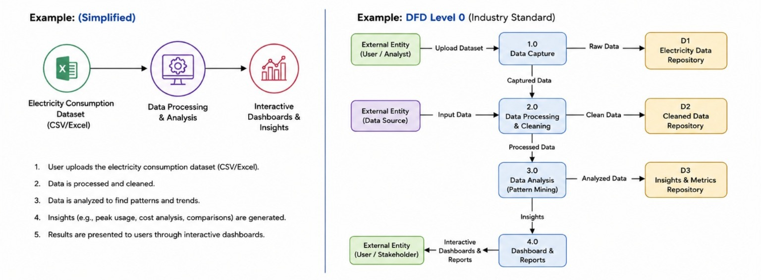

User Stories
Use the below template to list all the user stories for the product.
User Type | Functional Requirement (Epic) | User Story Number |  | User Story / Task | Acceptance Criteria | Priority | Release
Data Analyst | Data Upload | USN-1 |  | As a data analyst, I can upload the electricity consumption dataset into the system. | Dataset is uploaded successfully and ready for analysis. | High | Sprint-1
 | Data Validation | USN-2 |  | As a data analyst, I can validate the uploaded dataset for missing or incorrect values. | Invalid or missing data is identified and reported. | High | Sprint-1
 | Data Processing | USN-3 |  | As a data analyst, I can clean and prepare the dataset for visualization. | Cleaned data is stored and available for analysis. | High | Sprint-1
Dashboard User | Dashboard | USN-4 |  | As a user, I can view an interactive dashboard showing electricity consumption trends. | Dashboard displays charts and KPIs correctly. | High | Sprint-1
 | Trend Analysis | USN-5 |  | As a user, I can analyze monthly and yearly electricity consumption trends. | Trend charts update based on selected time period. | High | Sprint-1
 | State-wise Analysis | USN-6 |  | As a user, I can compare electricity consumption across different states. | State-wise comparison charts are displayed accurately. | High | Sprint-2
 | COVID-19 Impact Analysis | USN-7 |  | As a user, I can analyze electricity consumption before, during, and after the COVID-19 lockdown. | Dashboard displays comparisons for different periods. | Medium | Sprint-2
 | Filter Data | USN-8 |  | As a user, I can filter the dashboard by state, month, and year. | Visualizations update dynamically based on selected filters. | High | Sprint-2
 | Reports | USN-9 |  | As a user, I can download reports and dashboard summaries. | Reports are generated successfully in PDF or image format. | Medium | Sprint-3
Administrator | Data Management | USN-10 |  | As an administrator, I can update or replace the electricity consumption dataset. | New dataset is uploaded without affecting the dashboard. | High | Sprint-3
 | User Management | USN-11 |  | As an administrator, I can manage user access to the dashboard. | Authorized users can access the dashboard securely. | Medium | Sprint-3

